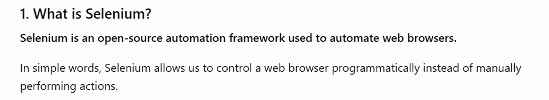
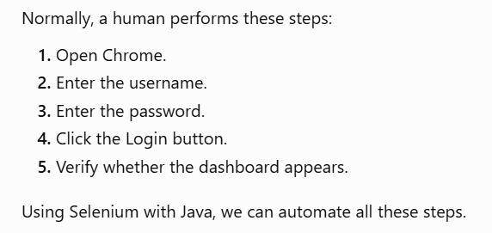
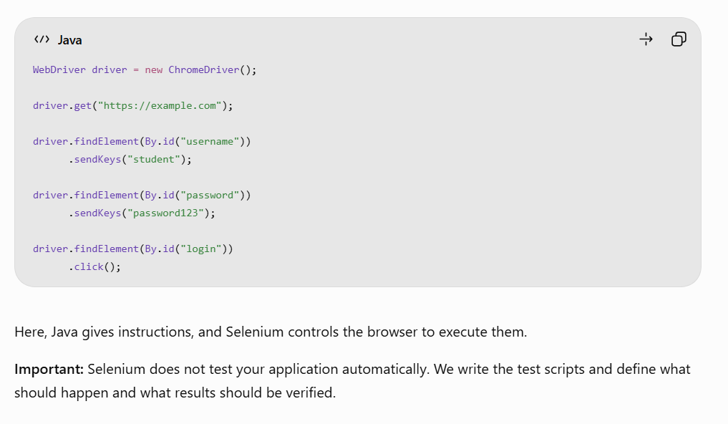
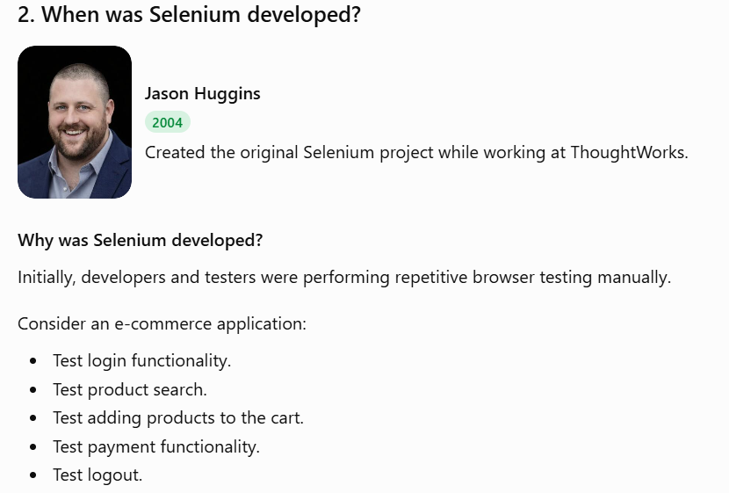
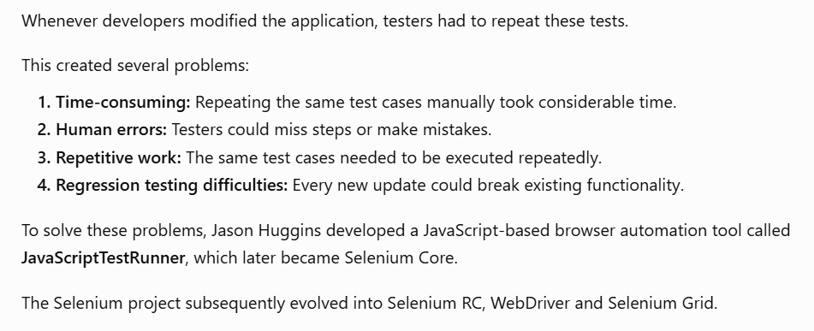
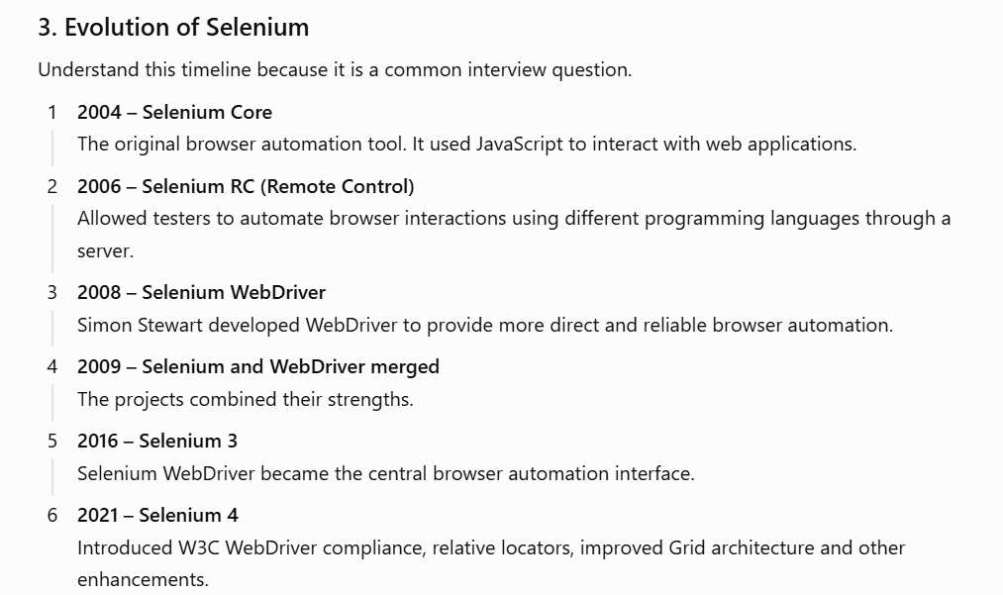

Use of Automation testing instead of Manual Testing : -
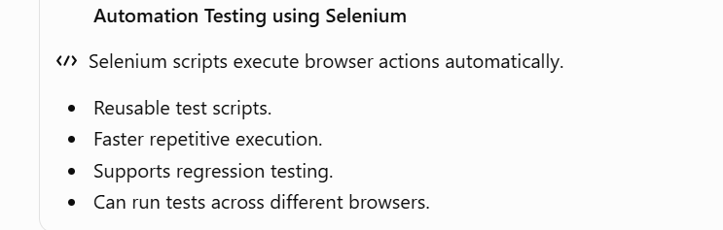
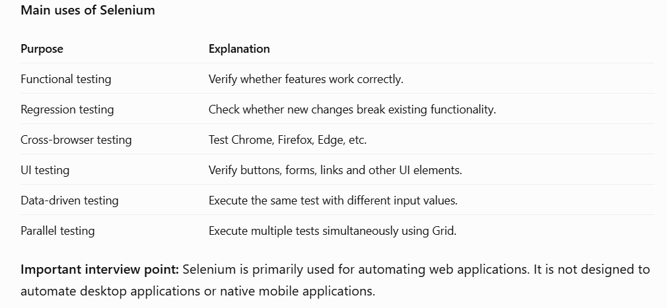
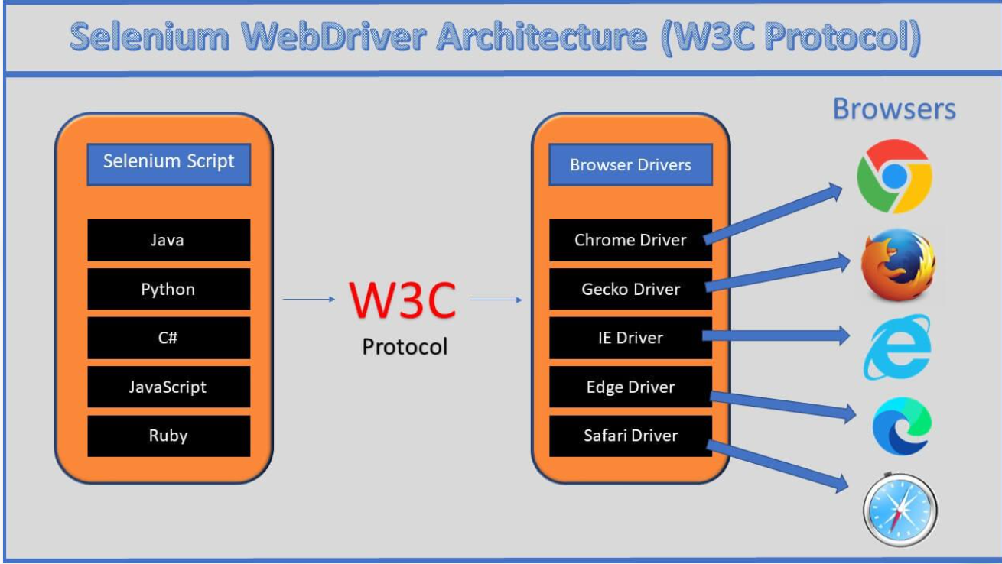
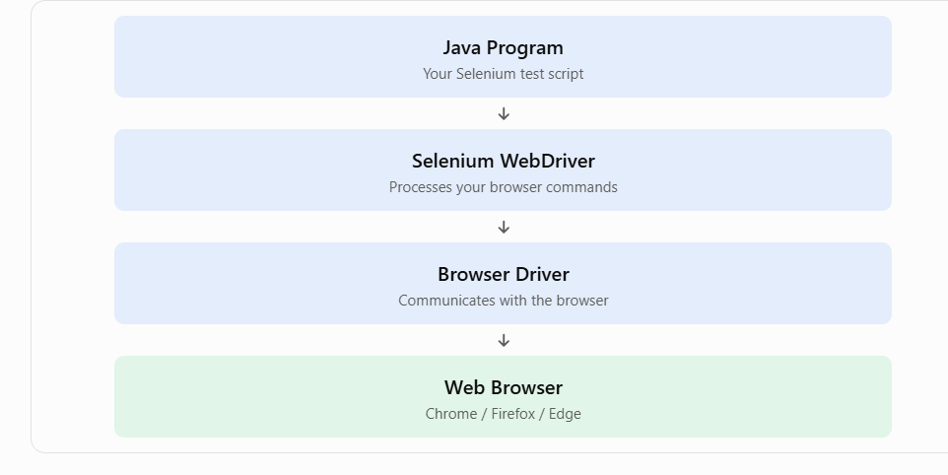
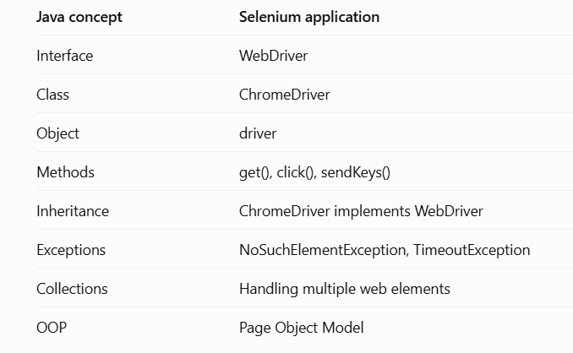

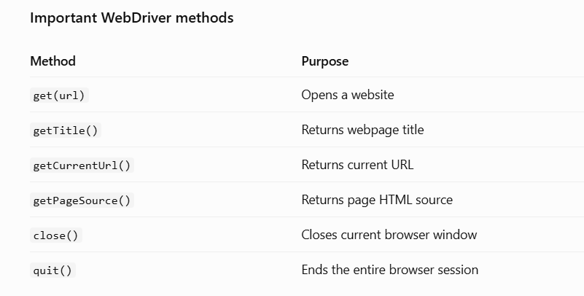

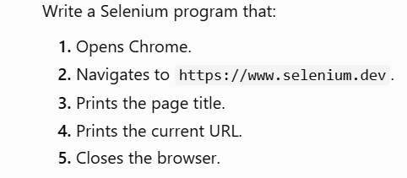

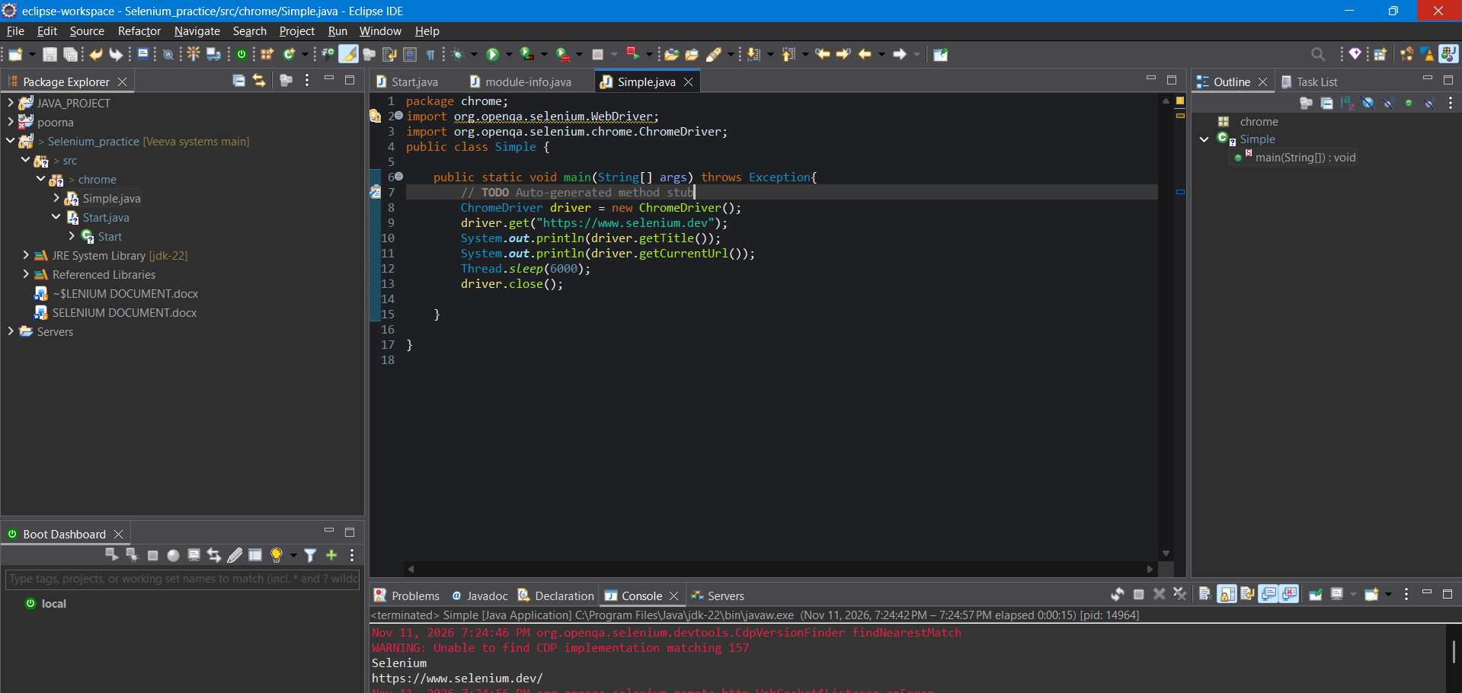

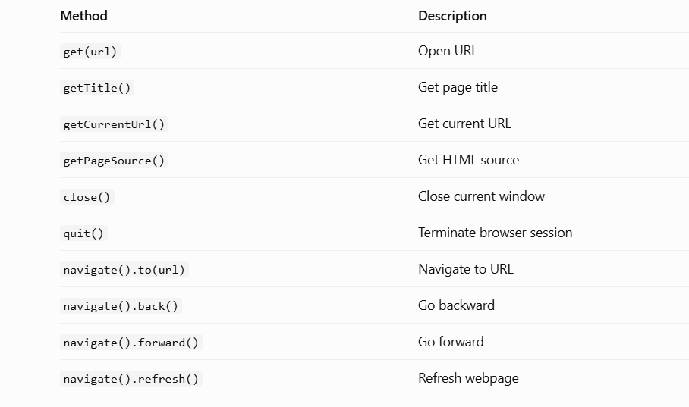

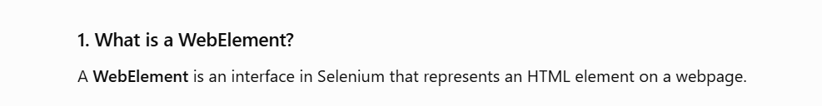
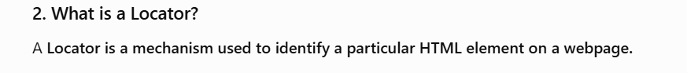
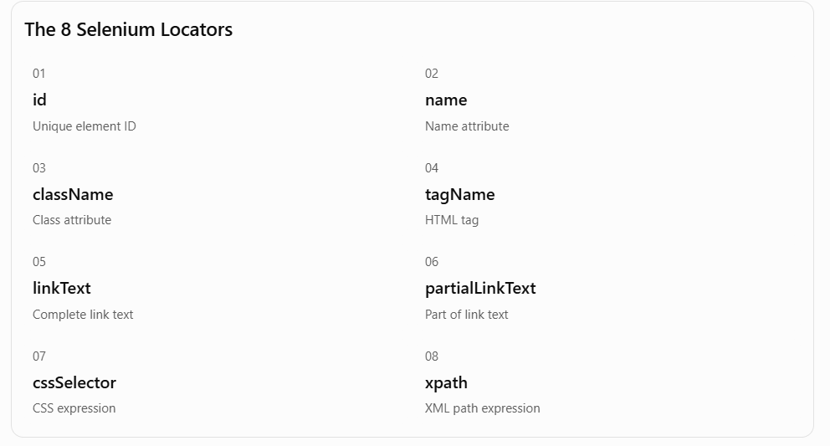


driver.findElement(By.id("username"));


driver.findElement(By.name("email"));


driver.findElement(By.className("form-control"));


driver.findElement(By.tagName("input"));


driver.findElement(By.linkText("Google"));


driver.findElement(By.partialLinkText("Google"));


driver.findElement(By.cssSelector("#username"));

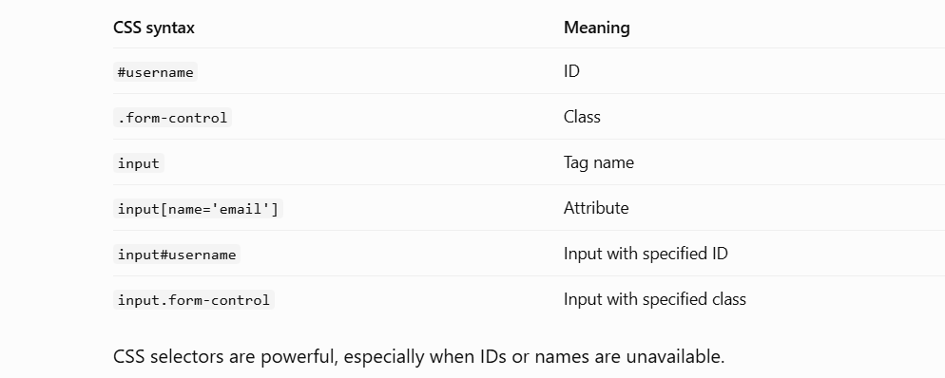

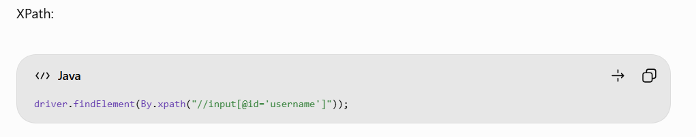
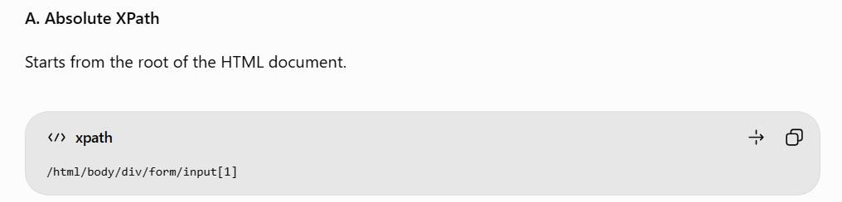
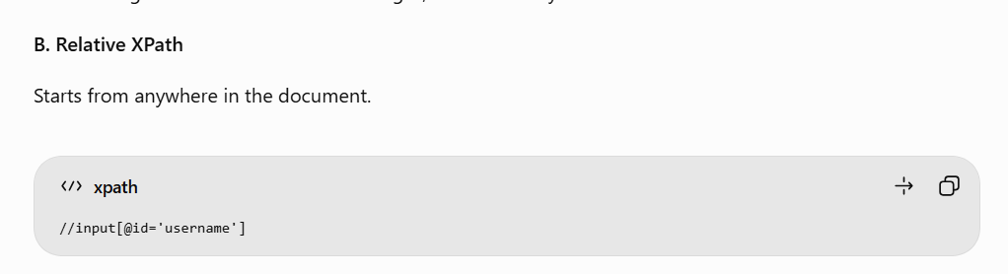
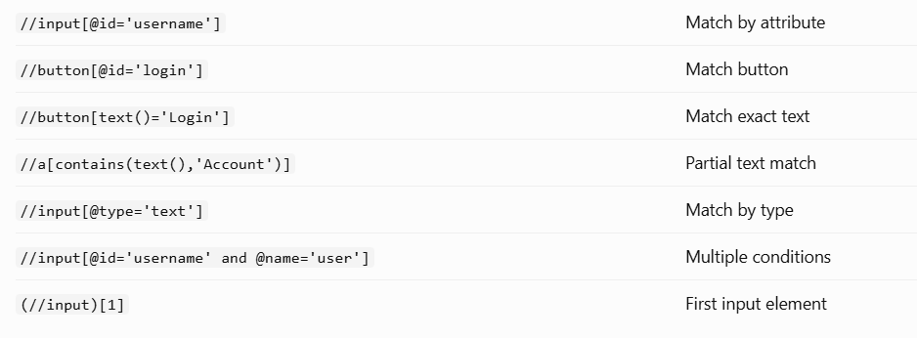
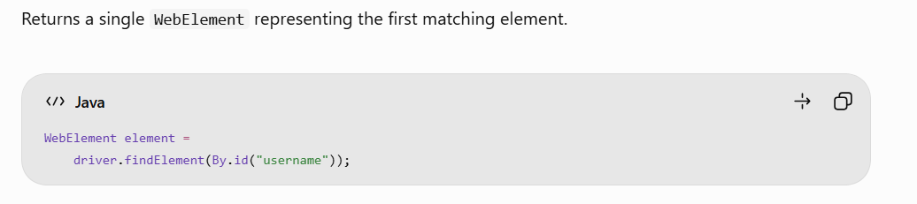
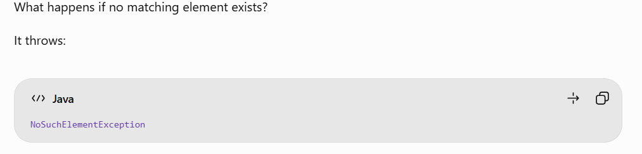
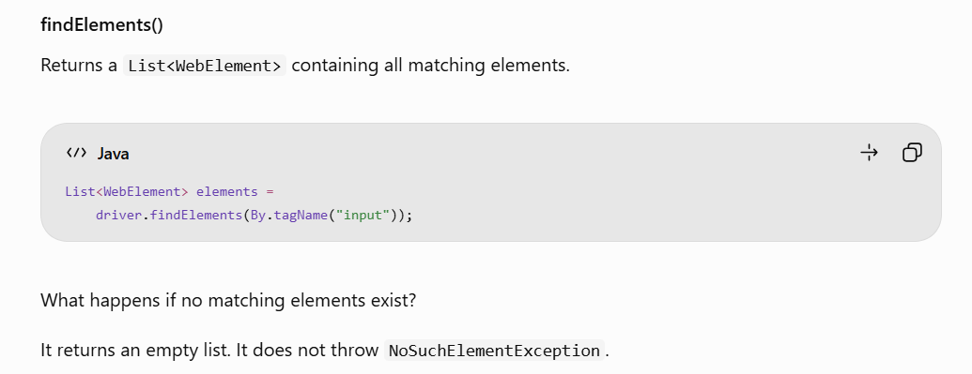
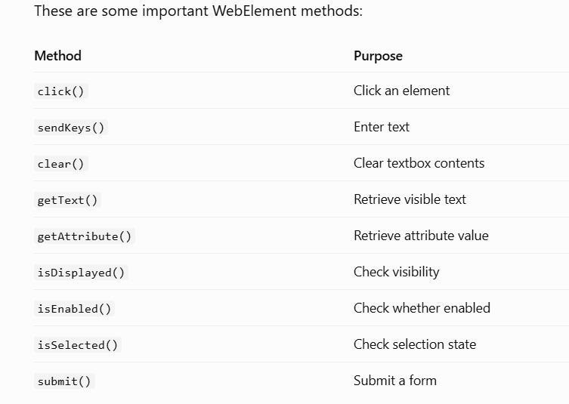
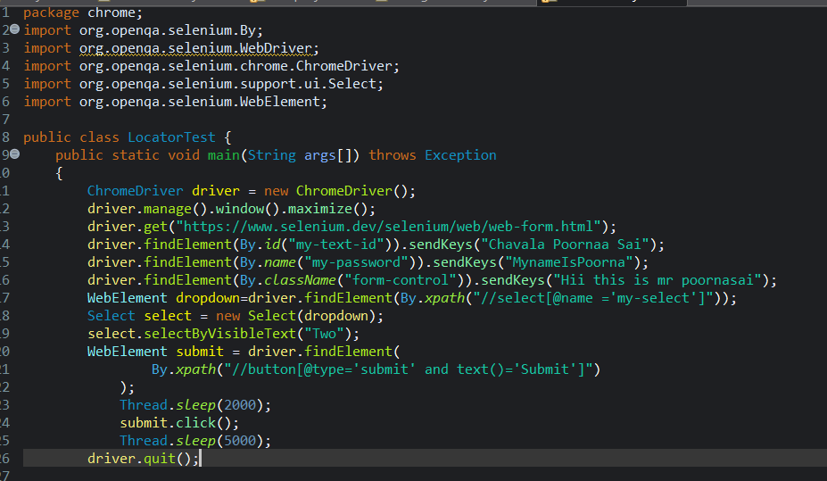

Xpath:
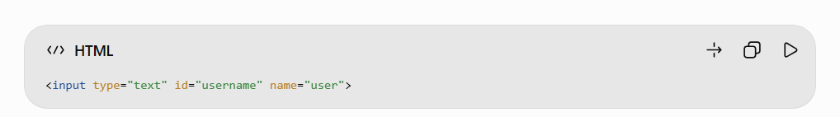
//input[@id='username']
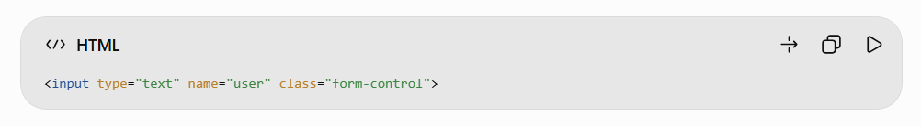
//input[@type='text' and @name='user'] (or) //input[@type='text' or @name='user']

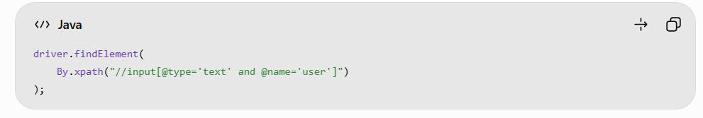
text() -
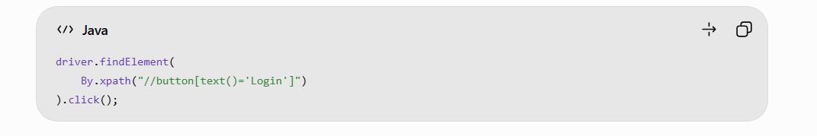
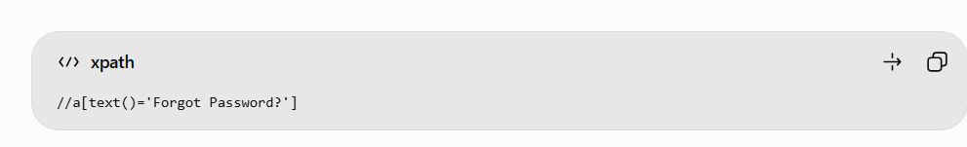
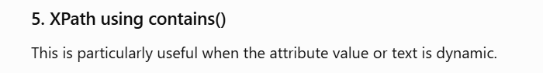
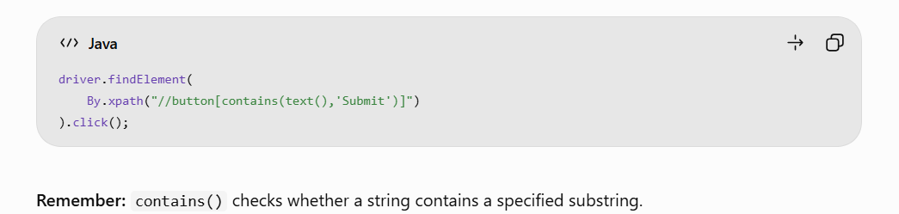
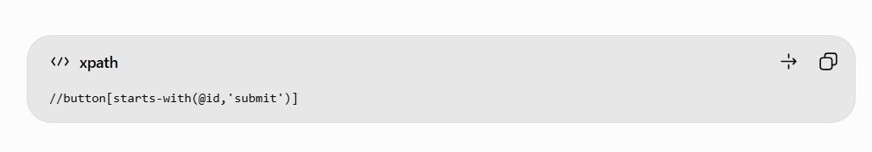
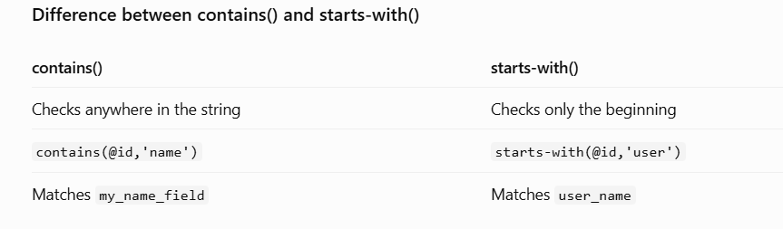
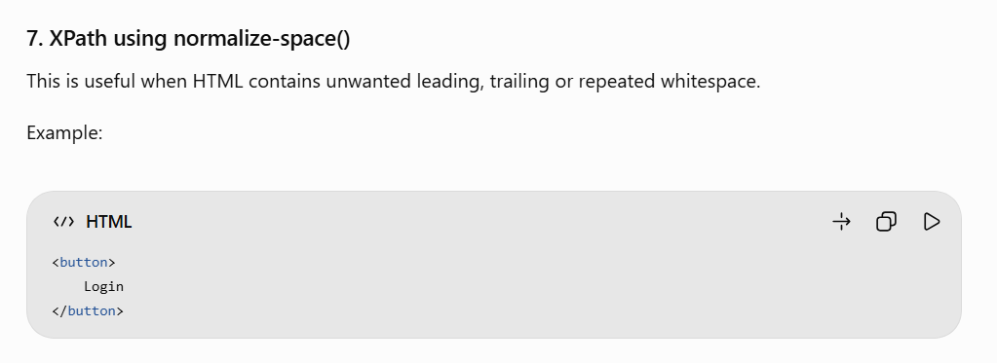
//button[normalize-space()='Login'].
<button> Submit Application </button>
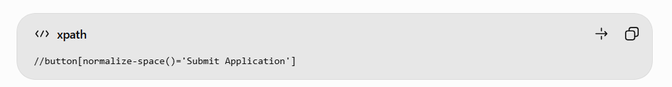
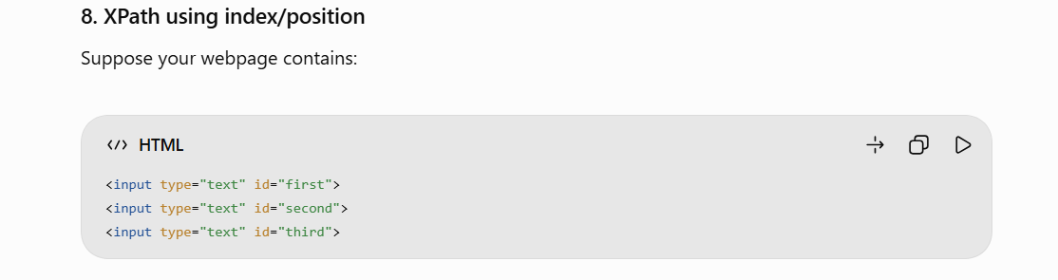
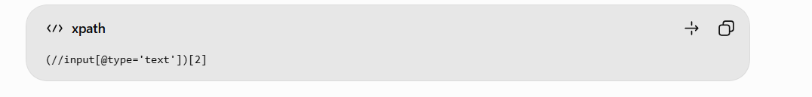

DropDown :
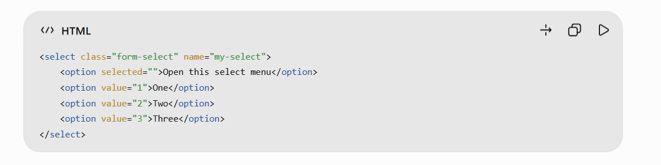
- driver.findElement(By.className("form-select"));
- driver.findElement(By.name("my-select"));
- driver.findElement(By.tagName("select"));
- driver.findElement(By.cssSelector("select.form-select"));
- driver.findElement(By.cssSelector("select[name='my-select']"));
- driver.findElement(By.xpath("//select"));
- driver.findElement(By.xpath("//select[@class='form-select']"));
- driver.findElement(By.xpath("//select[@name='my-select']"));
- driver.findElement(By.xpath("//select[@name='my-select' and @class='form-select']"));

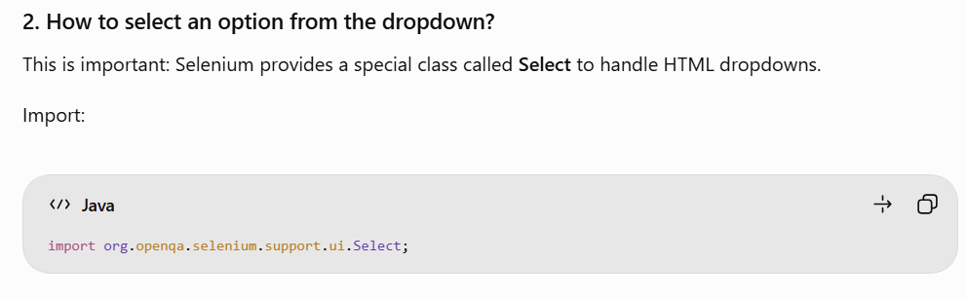

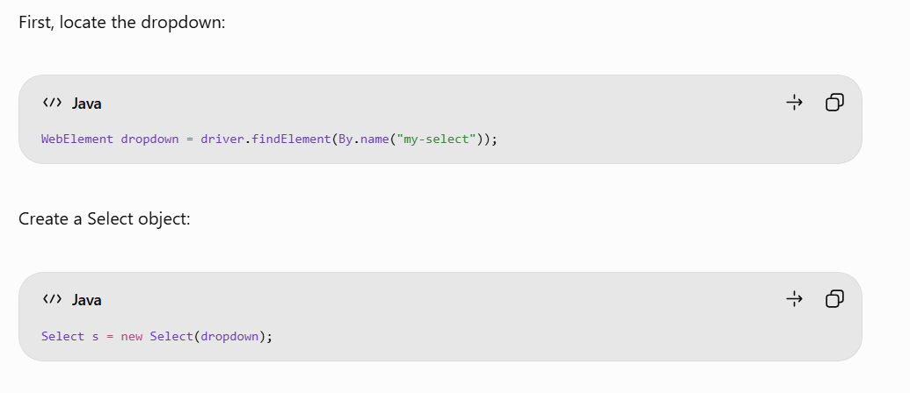

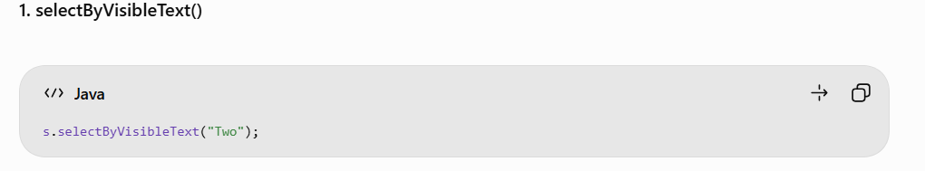
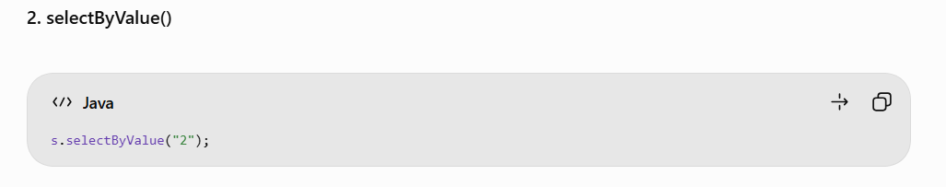
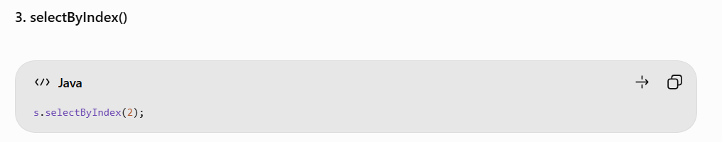
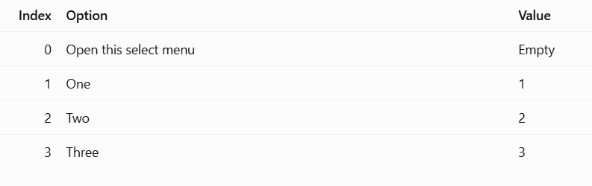Web Element Methods :

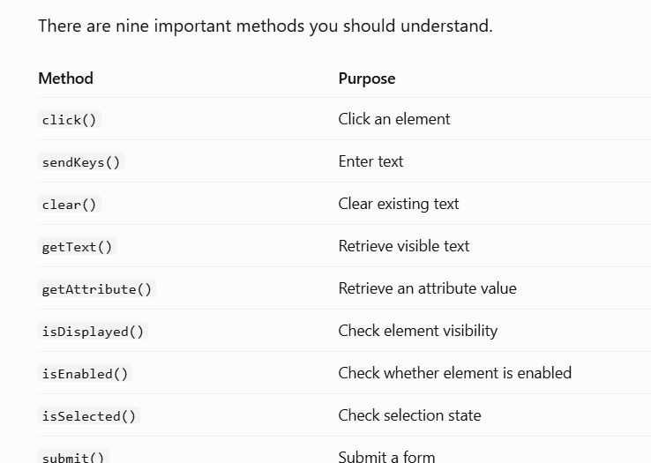

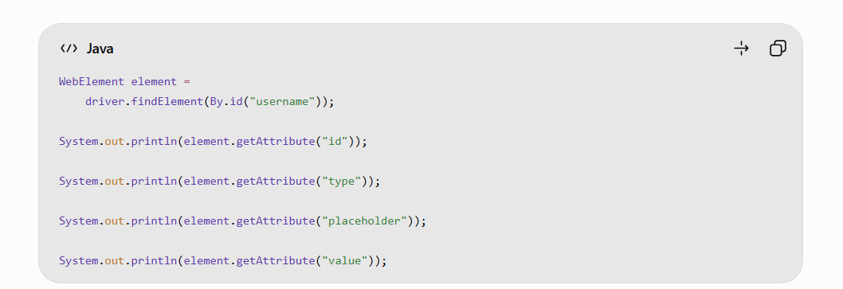
OUTPUT :
username
text
Enter username
Selenium



